**Color Image Compression Using Discrete Wavelet Transformation**

Image Processing Project Proposal

Khaled Yehia

2021/03399

**Introduction:**

In today’s day and age, digital storage space is becoming an increasingly scarce and high value resource owing to the fact that file sizes are only getting more and more demanding by the day. So, storage space optimization and efficient file compression must be put into consideration to counteract the growing requirements of file storage. This project aims to tackle color image compression to cut down file sizes while also preserving the original image quality. To achieve said high quality compression, using lossy Discrete Wavelet Transformation Techniques (DWT) is proposed. Discrete Wavelet transformations are mathematical functions having a limited duration and oscillate around a zero mean. They decompose a signal into a set of high frequency wavelet coefficients representing the fine details of the signal while utilizing other low frequency coefficients to show the coarser features of the signal.

Results yielded from using different wavelets

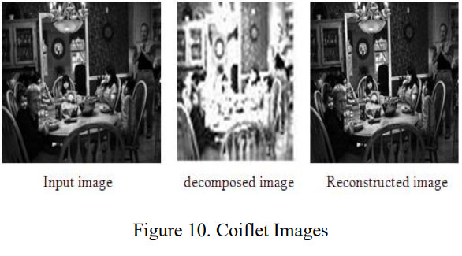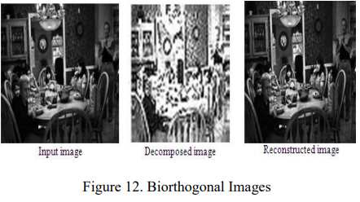

**Related Works:**

*Chowdhury, M. Mozammel Hoque, and Amina Khatun. Image Compression Using Discrete Wavelet Transform. July 2012:* This research paper strives to solve the issue of image compression by using Discrete Wavelet Transformations techniques. It also compares their results with those of other techniques. Ultimately, it was found that DWT provide effective high compression ratios while avoiding any noticeable degradation of image quality.

Link: <https://citeseerx.ist.psu.edu/document?repid=rep1&type=pdf&doi=0672059e723bf24180e9c42d6fa02b302498a826>

*Abdulelah, Asma Abdulrahman, et al. “The Application of Color Image Compression Based on Discrete Wavelet Transform.” Journal of Al-Qadisiyah for Computer Science and Mathematics, vol. 13, no. 1, 28 Feb. 2021:* The authors of this article sought out to test the efficacy of Discrete Wavelet Transformations in compressing colored images while using MATLAB software in their implementation. They arrived at the conclusion that DWT produced satisfactory results that turned out to be better than other proposed theories.

Link:

<https://www.iasj.net/iasj/download/fe495279ca286ce5>

*Sridhar, S., et al. “Wavelet Transform Techniques for Image Compression – an Evaluation.” International Journal of Image, Graphics and Signal Processing, vol. 6, no. 2, 8 Jan. 2014:* This paper tests out the results of using different types of Wavelets in image compression, with the end goal of evaluating and comparing their compressed images. They used different samples of images with varying degrees of detail and different color spaces.

Link:

<https://www.mecs-press.org/ijigsp/ijigsp-v6-n2/IJIGSP-V6-N2-7.pdf>

**Methodology:**

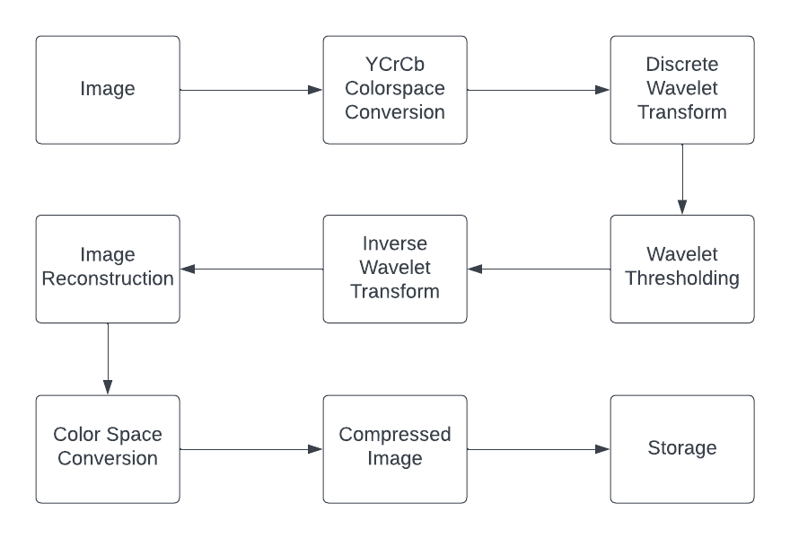

***Steps:***

1. ***Color space conversion:*** Convert to YCrCb to reduce channel correlation.
2. ***Wavelet transform:*** Apply DWT to each color channel decomposing the image to a set of wavelet coefficients.
3. ***Wavelet Thresholding:*** Threshold all color channel wavelets using a set threshold ratio.
4. ***Inverse Wavelet Transform:*** Convert channel wavelets back to YCrCb color channel arrays.
5. ***Image Reconstruction:*** Combine all 3 channels to form compressed image.
6. ***Color Space Conversion:*** Convert image back to BGR or RGB color spaces.
7. ***Storage:*** Save & store compressed image taking up less storage space.